Vassily Savenko bass-baritone

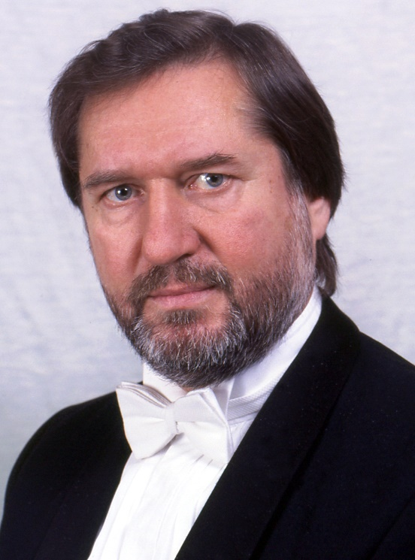
Vassily Savenko was born near Odessa, Ukraine. He began his vocal studies at the Nezhdanova Conservatory, Odessa and graduated from the Tchaikovsky Conservatory Moscow under Alexey Bolshakov - later with Mikhail Kiselev. He won both the Mussorgsky and Lysenko Competitions and sang principal roles for major opera houses in his native Ukraine and in Russia, including the Bolshoi Opera, Moscow, and the Kirov Opera, St Petersburg, where he sang Iago ( Otello ) under Gergiev.
In the early 90’s he moved to Britain where his debut at London’s Wigmore Hall launched the showcase vocal series Russian Images – a kaleidoscope of Russian Art Songs rarely heard in the West. Further series followed (all premiered at Wigmore Hall) Rachmaninov and Medtner, Russian Horizons and Pushkin in Music: works from these programmes were subsequently released on three CDs by Hyperion Records. A collaboration with pianist Boris Berezovsky focused on the wonderful songs of Nikolai Medtner and they have given recitals in the UK, Belgium, Russia and toured in Japan. A recording on the French label Mirare features some of this repertoire. “[His] fine voice revealed both the depth of his tone and the ringing power of its upper register. The pianist here was Tchaikovsky gold- medallist Boris Berezovsky.” Opera Now
UK Festival appearances include Cheltenham International Music, Hereford Autumn, Three Choirs, Rimsky-Korsakov, Oxford Lieder and The Proms at St Judes, Elswhere: The Kiev Music Fest, Moscow International Autumn, The Second International Medtner Festival (Russia), and The Kiev Easter Music Festival.

World premieres: Yuri Kasparov’s mono -opera Nevermore (Moscow Autumn Festival); Vadim Kulov’s Pushkin’s Spring with pianist Boris Berezovsky (Wigmore Hall); David Matthew’s Winter Passions with Nash Ensemble (Cheltenham Festival). United Kingdom premiers: Alexander Blok’s song cycle Dreams (Wigmore Hall); Boris Lyatoshinsky’s Two Romances (Bristol St George’s); Edison Denisov’s Merry Time for Voice and Trio; Alexander Mosolov’s Three Pushkin Settings with Michael Dussek (Wigmore Hall) and Sviridov’s Burns Songs with Alexander Blok (Wigmore Hall). The Scottish premiere of his cycle was given at Balquhidder Summer Music. “Burns to set the heather afire…an exhilarating experience” The Herald

Concert work with orchestras include operatic scenes/arias and song cycles. Highlights include Mussorgsky’s Song and Dances of Death in Sweden, and Shostakovich’s 10 Songs of the Fool (from King Lear) with the BBC’s Symphony Orchestra at London’s Maida Vale Studios. He is due to perform in Rachmaninov’s The Bells and Mussorgsky’s Songs and Dances of Death for Cambridge Philharmonic in May 2020.

In opera, Savenko made his UK debut in a Rachmaninov double-bill, interpreting the dual roles of Baron - Miserly Knight and Lanciotto Malatesta – Francesca da Rimini, to great acclaim. “Vassily Savenko was an excellent choice, tortured and vengeful as Lanciotto Malatesta, mean and mad-eyed as the Baron in the Miserly Knight but keeping the histrionics in check” Geoffrey Norris, The Daily Telegraph.

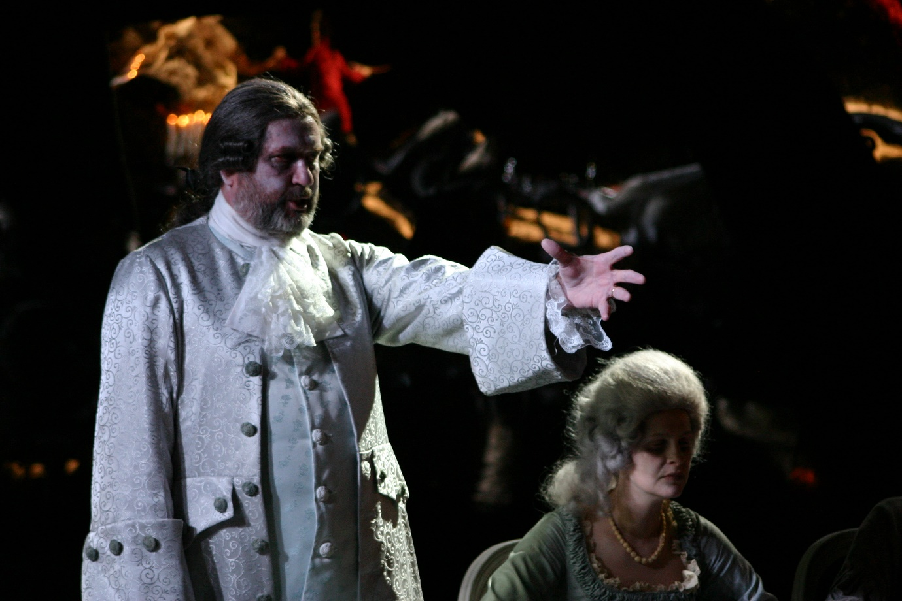

He has performed principal roles with the following conductors/directors:
Gennadi Rozhdestvensky - Teatro Lirico di Cagliari, Tchaikovsky “Oprichnik” director: Graham Vick role: Prince Gemchuzhny.
Alexander Lazarev – RSNO concert performance, Tchaikovsky “Iolanta” role: Ebbn-Khakia.
Alexander Anissimov – Opera Ireland, Tchaikovsky “The Queen of spades” role: Count Tomsky.
Nikolai Alexeev – Netherlands Radio Symphony Orchestra, in concert, Rachmaninov “Francesca da Rimini” role: Lanciotto Malatesta.
Alberto Hold-Garrido - WNO Verdi “Il Trovatore” role: Ferrando.
Alexander Polianichko -WNO Tchaikovsky “Mazeppa” role: Mazeppa (cover)
David Lloyd- Jones - Grange Park Opera, Tchaikovsky “Enchantress” director - David Fielding, role:
Prince Nikita.
Stefan Solyom – GPO, Mozart “Don Giovanni” director: Daniel Slater, role: Commendatore
Enrico Dovico - State Theatre Klagenfurt, Austria, Mozart “Don Giovanni” director: Dietmar Pflegerl, role: Commendatore,
Teatro Nacional de Sao Carlos Lisbon, Tchaikovsky “Enchantress” director: David Poutney, role: Foka
Mark Elder – ROH Covent Garden, Rimsky- Korsakov “Tsar’s Bride”, director: Paul Curran, role: Sobakin (cover)

Highlights include:
Vladimir Garkusha - Boris Godunov, State Academic Opera & Ballet Theatre, Ukraine, director: Yuri Chaika, role: Title role
Emmanuel Villaume - November 2012 extensive European tour of Tchaikovsky’s Iolanta with Anna Netrebko as Iolanta. Role Ebn-Khakia. Vassily was subsequently invited to repeat this role for Santa Cecilia Rome, under Maestro Antonio Pappano.

