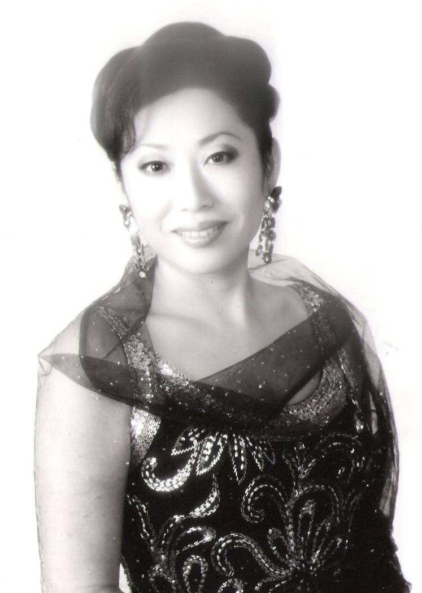
Makiko Awazu, Soprano

Biography

Born and raised in Tokyo, Canadian soprano, Makiko Awazu has been acclaimed for her poignant performances in Japan and throughout Europe. She is particularly appreciated for her riveting portrayal of Cio Cio San in Madama Butterfly, a role she has performed nearly 100 times.
After graduating from the University of Fine Arts in Tokyo, she wins first prize in the Kansai Italian Japanese Voice Competition and a Scholarship to study at the Guiseppe Verdi Conservatory of Music in Milano. She graduates in Vocal Studies, studying with renowned singers Giu1ietta Simionato and Gino Bechi. She also studied in Italy with such renowned singers as Franco Corelli and Arrigo Pola (Pavarotti’s teacher).
She debuts in Europe at the Yugoslavia Music Festival, singing Norina in Don Pasquale with the Belgrade Symphony and in Japan she sings Amelia in Simon Boccanegra and her first Cio Cio San in Madama Butterfly at the Kansai Opera accompanied by La Scala baritone, Giorgio Lormi. She later begins a collaboration with the Tokyo Opera Lirica Italiana reprising Cio Cio San (1998), Violetta in La Traviata (1999), Mimi in La Boheme (2000), and Susama in Nozze Di Figaro (2002), with conductor, Renato Palumbo, assistant of the Lyric Opera of Chicago.
In Europe. she has sung Leonora in II Trovatore in over 25 performances in various cities in Austria, Germany, Switzerland, and Norway . She continues her success as Cio Cio San in Madama Butterfly singing in another 20 performances across Switzerland and Germany.
Her operatic work is complemented by her numerous concerts in Japan and Italy, in particular her concert in honor of the Chinese Government at the Tokyo Forum with the Tokyo Philhamonic Orchestra and her concert at Expo '96 in Genova were broadcast on TV in Japan and Italy respectively.

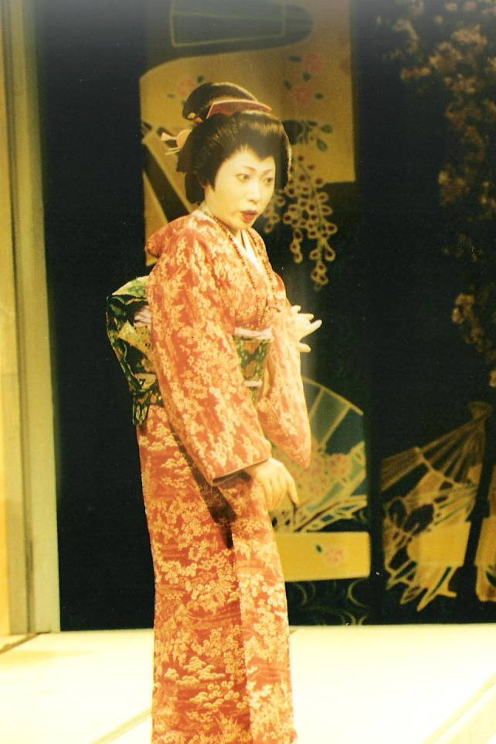
She makes her Canadian debut in the Messa di Requiem by Verdi in Montreal with the Philharmonic Society Orchestra directed by Miklos Takacs in 2000. She adds Petite Messe Solennelle by Rossini and the composer’s Stabat Mater to her oratorio repertoire in 2002.
In June 2007 she sang a solo concert at the Palais Montcalm in Quebec City and sang in August at the Salle Pauline Julien in Pierrefonds and in Trois Rivieres. In April 2008 she sings Maddalena in Andrea Chenier in Montreal with the Orchestra and Chorale Cantabile. In June, she is in concert with the New Jersey State Opera in Newark and in August with the Montreal Chamber Orchestra.
In April 2009 she debuts Santuzza in Cavalleria Rusticana in Montreal with the Il Canto Opera Association conducted by Peter Willsher and reprises Madama Butterfly with Pellegrini Opera in Ottawa. Upcoming events include Verdi Requiem with New Jersey State Opera at the 6000 seat Ocean Grove Auditorium in September, followed by Leonora in Il Trovatore at the Zolota Corona Festival in Donetsk and a Gala Concert with the Lithuania Orchestra in October 2009.

Agent :

Manrico Biscotti
Dietsch International Associates
Tel/fax 514 4576458
Email : biscotti@dietschartists.com

Makiko Awazu, Soprano
Operatic Repertoire

Composer Opera Role

Donizetti Don Pasquale Norina

Mozart Le Nozze di Figaro Susanna

Puccini La Boheme Mimi
Madama Butterfly Cio Cio San
Tosca Tosca
Turandot Liu

Verdi un Ballo in Maschera Amelia
Messa di Requiem Soprano
La Traviata Violetta
Il Trovatore Leonora
Simon Boccanegra Amelia

Leoncavallo Pagliacci Nedda

