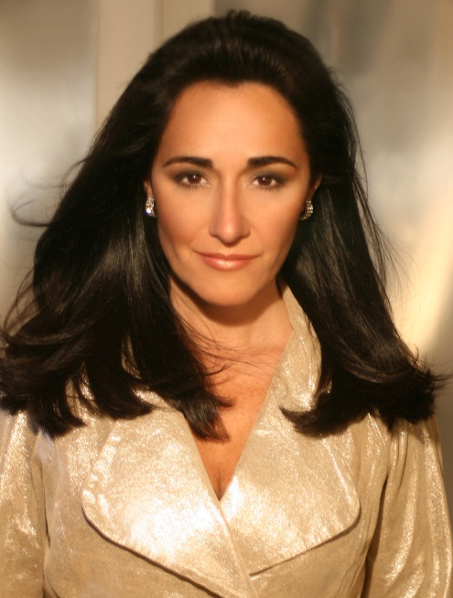
Desiree Halac, Mezzo-soprano
Biography

Argentinean mezzo-soprano, Desiree Halac is a versatile singer who is equally at home on the operatic, concert and recital stages. A passionate singer she has excelled in operas by Mozart, Handel, Rossini, Bellini, Offenbach and Strauss, though for some her true role is Bizet’s Carmen. On the concert stage she has collaborated with the late Jens Nygaard, Leon Botstein, Tanya Leon, David Zinman among others.

She collaborated with pianist Dalton Baldwin in a recording of songs by Argentinean Composer Carlos Guastavino named “Flores Argentinas” which was released this past July by Albany Records. Next season she sings the role of Angelina in La Cenerentolla with the New Jersey State Opera in USA and sings the role of Emma Jones with the Toulon Opera.

Her performance of the Muse and Nicklausse in Les Contes d'Hoffmann at the Aspen Festival, conducted by John DeMain, "gave the role the stature it deserves but seldom gets," according to the Denver Post. She returned to the Aspen Festival to sing the roles of Maria Rojas Harper in Bernard Rands World Premiere “Belladonna” conducted by David Zinmann.

At the Teatro Colon in Buenos Aires she sang the role of Dido in Dido and Aeneas and performed and recorded the role of Sorceress with I Muisci di San Cassiano under Bradley Brookshire with Vox Label. With I Musici di San Cassiano she also performed the title role of Monteverdi’s L’Arianna for Amnesty International in NY City.

With the Virginia Opera she sang the role of Rosina in Il Barbiere de Siviglia Papagena and the Second Lady in Die Zauberflote. Of her portrayal of Rosina the Viringia Post wrote: “She sailed through the challenging coloratura “una voce poco fa” maneuvering her voice through the dazzling coloratura. She remained at this high level the rest of the evening.” She appeared as Suzuki in Madama Butterfly with DiCapo Opera Theater under the baton of Anton Coppola and sang Dryad in Ariadne auf Naxos with the Metamorphoses Orchestra of New York.

“A sinuous, flowing Carmen” as described my the New York Times, Ms. Halac has performed the role in New York with the Mannes Ensemble, toured in 2008 with the St. Petesburgh Orchestra in Florida and sang the role at LSU, Louisiana.

With the Washington Concert Opera, she sang Rychtarka, the Mayor's wife, in Janacek's Jenufa. At the Festival Am Kloster in Germany, she sang Farnace in Mozart's Mitridate, Re di Ponto, Idamante in Idomeneo and Annio in La Clemenza di Tito, role which she sang also in Merkin Hall, NY with the Elysium Opera.

With the Mannes College of Music where she studied she was featured as Romeo in I Capuletti e i Montecchi; Zenobia in Handel's Radamisto and Despina in Cosi fan Tutte, both conducted by Will Crutchfield; Fair Welcome and Shame in The Romance of the Rose, a 15 century drama realized and directed by Paul Echols; and Cherubino in Le Nozze di Figaro.

Contemporary opera has been an important aspect of Ms. Halac's career: she sang the role of Marina Rojas Harper in Bernard Rand's world premiere "Belladonna" at the Aspen Festival", conducted by David Zinmann; the Queen in John Harbison's "A Full Moon in March" for the Encompass Opera Theatre in New York City. At the Guggenheim Museum, she sang in the world Premiere of Jonathan Dawe's Prometheus. She sang the title role in Maria de Buenos Aires organized by the Argentinean Embassy and the Pan-American Orchestra in Washington, the world premiere of Gilgamesh by Steven Dickman, at La Mama E.T.C. with the established S.E.M Ensemble, of which Anne Midgette observed in The New York Times that she "gave a performance in the best sense of the word, and turning each gesture into a moment of significance.”

Concert and Chamber music appearances have included Luigi Nono's Epitaph No. 3 with the American Symphony Orchestra and conductor Leon Botstein at Avery Fisher Hall. With the American Composers Orchestra works by Terzian and Gandini with conductor Paul Dunkel,

She performed the B minor Mass with the New York Metamorphoses Orchestra and the Choral Society at Grace Church, Handel's Dixit Dominus and Vivaldi's Gloria with the Westchester Choral, Bach's Magnificat, Beethoven's Mass in C Major and Mozart's Requiem, with the New the New England Symphonic Ensemble at Carnegie Hall. With the Crested Butte Music Festival she sang Haydn's Lord Nelson Mass, Theresian Mass and Paukenmesse. She appeared in the staged and controversial Millennial Arts staged production of Messiah, conducted by Kenneth Hamrick.

With the St.Luke's Orchestra Chamber Players she appeared as narrator in Stravinsky's "A Soldier's Tale” and singing Poulenc's"Leocadia", Mozart Arias, Montsalvatge's Five Black Songs, La Nuit D'Ete by Berlioz with the Jupiter Symphony, She appeard in the roles of Sangaride in Atys by Lully, in the title role of Medea by Charpeniter in Masterclasses with William Christie and Les Ars Florissans.

A strong exponent of art Song, Ms. Halac made her recital debut in New York's Merkin Hall in 2000, as winner of the prestigious Joy in Singing Award. She subsequently was the winner of the Jennie Tourel Prize at the Poulenc Plus! Competitiion, the Shoshana Foundation Award and Aspen Song Competition.

Ms.Halac has performed extensively in Portugal, Spain, England, the United States and Argentina in recital. "Desiree Halac and pianist Max Lifchitz joined in a terrific concert titled simply "Songs from Latin America"Halac is a marvelous singer who creates a moment of extreme intimacy in each song she sings. What a concert - it will stay a long time in the musical memory" Albany Times Union.

Ms. Halac was born in New York and grew up in Argentina. She studied at the National Conservatory in Buenos Aires and then went to London where she began her vocal studies at the Mayer Lismann Opera Workshop. She was subsequently given a scholarship to the Mannes College of Music in New York.

