Lucia Hyunju Song, Coloratura Soprano
Biography

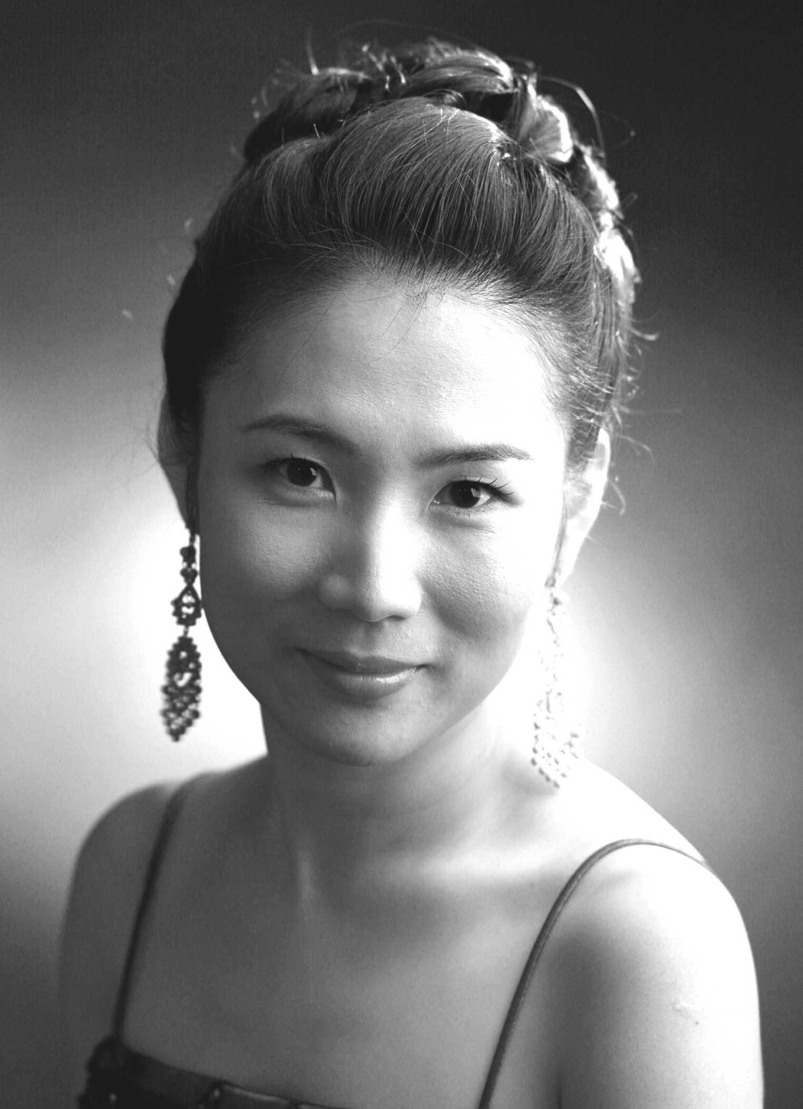
Soprano Lucia H Song, widely praised for her vocal talents and refined musicianship, and described by Opera News as ‘an exceptionally lovely voice, exquisitely touching’.

She was the winner of the German Lieder Society Competition and first prizewinner from William Garrison Competition, also she received Best Interpretation Award from Baltimore Washington chapter of the American Liszt Society. She was one of the recipients of the 2003-2005 New Triad for Collaborative Arts fellowship awards, for which she was awarded to perform concerts in and around New York.

As a concert artist, Ms. Song sings with the numerous orchestras, and has appeared as a soloist in Schubert’s C Major Mass, Bach’s Magnificat, Mozart’s C minor Mass, and Mozart’s Requiem. She has been invited to perform at Penn Alps “Schrock Memorial Concert” which was sponsored by the Alta Schrock Memorial Fund, “9-11 Remembrance Ceremony” in New Jersey, “Washington Square Music Festival” and “Midday Concert at the United Nations” at Dag Hammarskjold Auditorium.

This last Fall she makes her New Jersey State Opera debut as the Soprano in La Serva Padrona by Pergolesi. She made her opera debut in the title role in Hänsel und Gretel at the National Theater of Korea. Her operatic roles include Rosina in Il Barbiere di Siviglia, Adina in L’Elisir d’Amor, Pamina and Königin der Nacht in Die Zauberflöte, Gilda in Rigoletto, First Witch in Dido and Aeneas and The Widow in The Boor by Dominick Argento.

She holds a Doctorate degree from Stonybrook NYS, and master’s degree and a professional diploma from the Manhattan School of Music, where she studied with Hilda Harris with a full scholarship.

