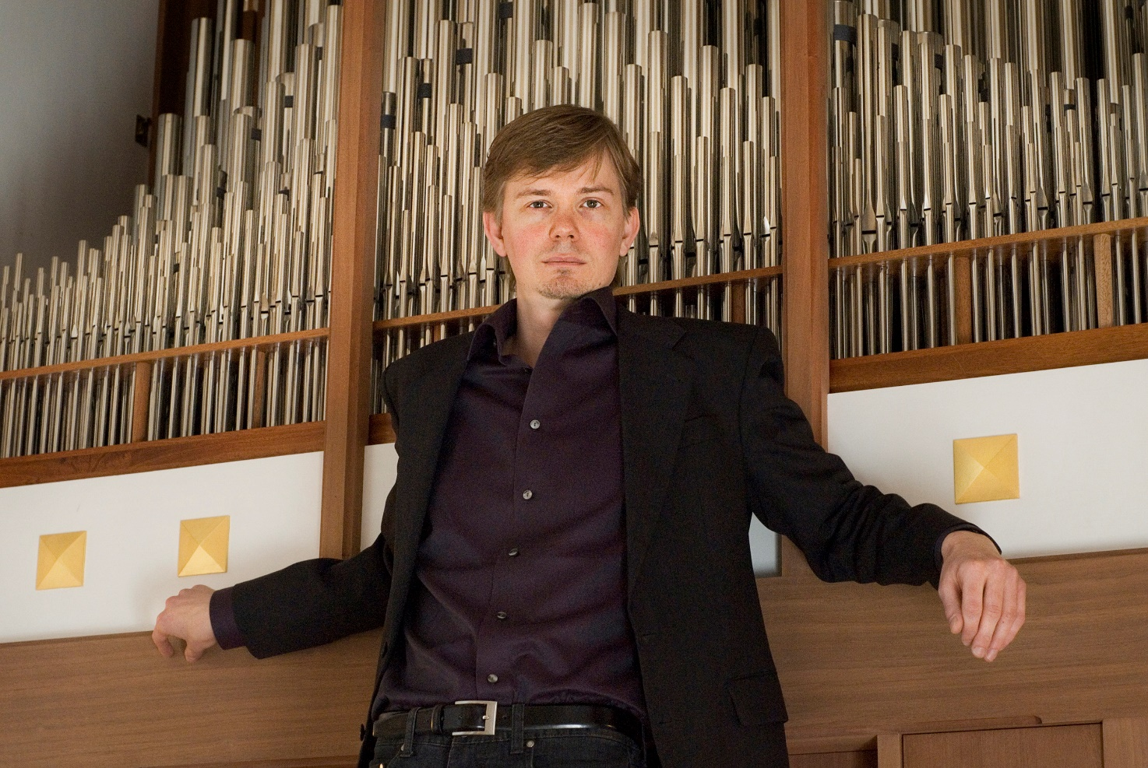
Frederik Magle, contemporary composer, concert organist and pianist.
His music has been performed by The London Philharmonic Orchestra, Zürcher Kammerorchester, The Danish National Symphony Orchestra, Danish National Chamber Orchestra, Riga Philharmonic Orchestra, South-Jutland Symphony Orchestra, Nikolaj Znaider and many other ensembles and soloists.
The world premiere performances of Frederik Mangle’s symphonic suite »Cantabile« ( text by H.R.H. Henrik, the late prince consort of Denmark) took place at two televised gala concerts.
The first movement »Souffle le vent« was premiered in 2004 and the two remaining movements - »Cortège & Dance Macabre« and »Carillon« - were premiered on June 10th, 2009, by the Danish National Symphony Orchestra and Chorus, at a gala concert in celebration of H.R.H. the Prince Consort's 75th birthday.
Frederik Magle also works with film scores and crossover music/fusion, blending contemporary classical music with another genre such as jazz, rock, electronica, and even hip-hop.
On October 25th, 2009 the first pipe organ with tonal design by Frederik Magle was inaugurated in Jørlunde church, Denmark. The instrument has 24 stops and 1360 pipes and is built by the organ builders Frobenius on specifications by Frederik Magle, who as hired as a consultant by the church council. (Essay about the pipe organ).
As a soloist on piano or pipe organ, Frederik Magle has played in Peter's Basilica (Rome), Windsor Castle, Luzern Concert Hall, Riga Cathedral, Konserthuset (Copenhagen Concert Hall), The Danish Radio Concert Hall, and many other places. In 1999 Frederik played at the christening of H.H. Prince Nikolai, and later he was invited to perform a solo organ concert for the Danish Royal Family and Royal Court at Fredensborg Castle. In 2002 his piece »Pact of the Baptism« was given its first performance at the christening of H.H. Prince Felix in Møgeltønder Church.
Frederik Magle has also received many grants and prizes in support of his work and achievements as composer and musician, including the Grants of Her Majesty the Queen of Denmark and H.R.H. Prince Henrik, The Grant of H.H. Prince Joachim and H.H. Princess Alexandra, Countess Erna Hamilton's scholarship, Carlsberg's Prize of Ideas, Unibank's Arts Prize, the Arts Award of the Freemasons, and a grant from the Danish Arts Foundation (2014). Frederik Magle was chosen by the Royal family to play at the Castor Dolores of his Royal Highness Prince Henrik of Denmark - televised to several nations worldwide.

