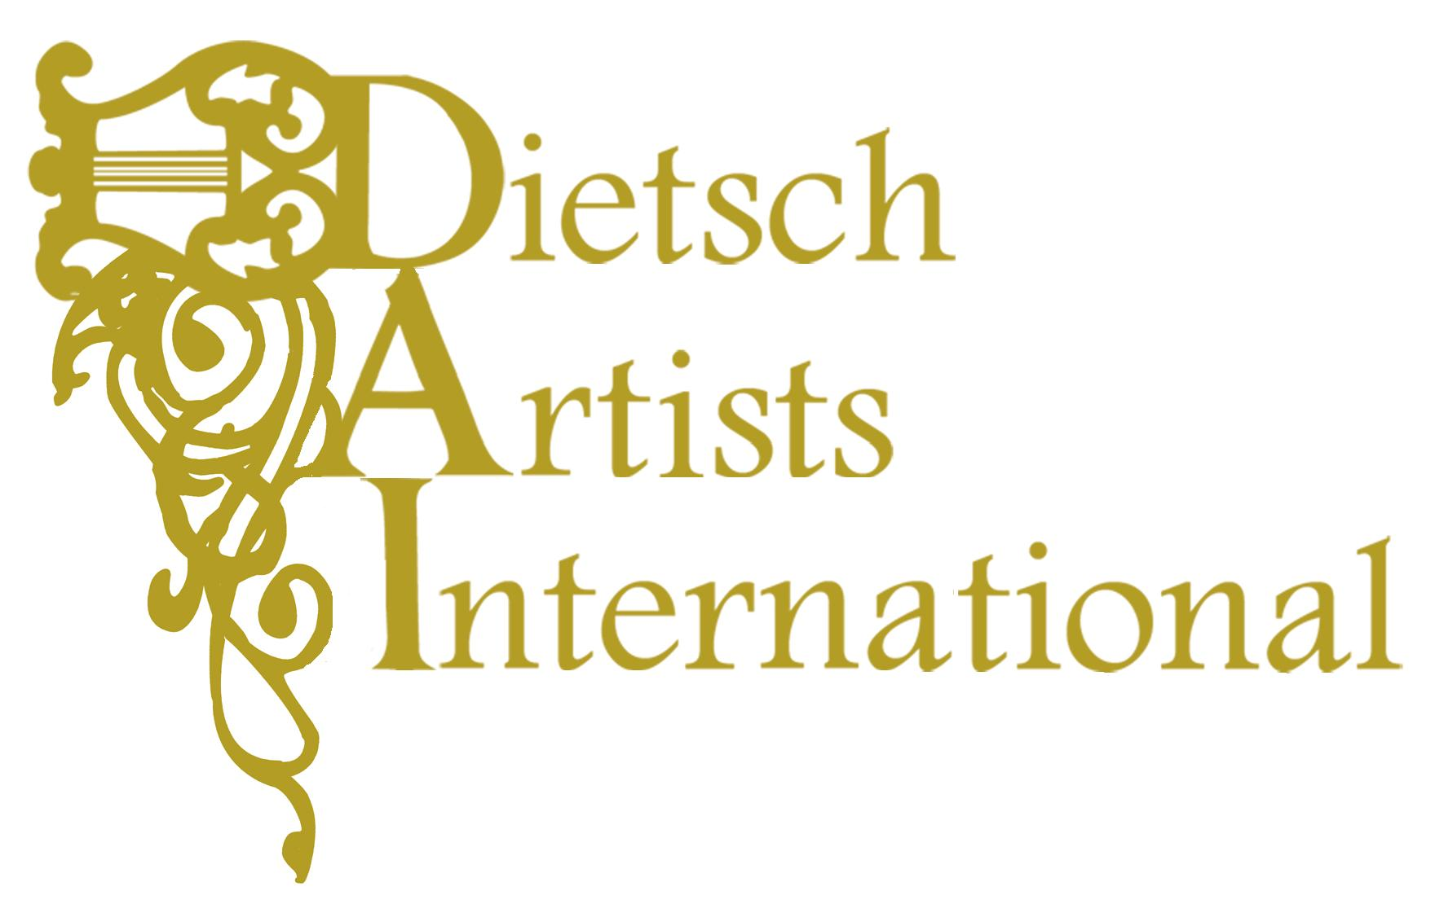 | James Dietsch, President  dietsch@dietschartists.com  143 S. Centre St.  South Orange, NJ 07079  phone: +1 973-763-8836  fax: +1 973-763-8837

Zarui Vardanean, Mezzo Soprano

AWARDS

Honored Artist of the Republic of Moldova (2011)
Master of Fine Arts in Music
The First Prize Winner at the National A.Stirchea’s Opera Singers Competition (Moldova, Chisinau, 1995).
Diploma of Honor Recipient at the H.Darclee’s International Competition (Romania, Braila, 1999)
Scholarship of the Central and Eastern European Musiktheater (Austria, Vienna, 2004-2005).

WORK EXPERIENCE:

September 2006 to the present time soloist of the Opera and Ballet International Company (UK)
September 2009 - 2013 – Vocal teacher of Academy of Music, Theatre and Fine Arts Rep. of Moldova
August 1998 - 2013 - soloist of National Opera and Ballet Theatre Rep. of Moldova
From March 1998 to the present time the permanent guest singer of the Moldavian National Philharmonic. S. Lunkevichi
From March 2000 to the present time the permanent guest singer of the National Symphony Orchestra of Radio and Television of the Republic of Moldova
March 1991 – 1998 soloist of the chorus of National Opera and Ballet Theatre Rep. of Moldova

EDUCATION:

2011–2013 Diploma of Institute of Continuing Education of the Republic of Moldova; Faculty of socio - economic; Specialty Business Management and Administration; Qualifications – manager:1994–1998 Diploma of Gavril Muzichesku Academy of Music Rep. of Moldova; Specialty Academic Singing; Qualification - opera soloist; performer of chamber vocal music; music teacher:1985–1991 Diploma of Gavril Muzichesku Moldova State Conservatory; Specialty choral conducting; Qualification - chorus conductor; teacher of choral disciplines:1981–1985 Diploma of Balti school teacher; Specialty choral conducting; Qualification - chorus conductor; teacher of music; solfeggio teacher:

FESTIVALS:

The International Festival “Va Invita M.Biesu” (1998 – 2013)
The “Days of Russian Culture Festival “in Chisinau, Moldova (2004)
The 8th International Festival of Performance Art “Bitei”, organized by “E.Ionescu” theatre (2007)
The International Festival “Martishor” (1998-2013)
The International Festival "Crizantema de Aur" (2011)
The International Festival “Opera Nights” (Hunedoara, Transylvania 2013)

MASTER CLASSES AND COACHES;

Constantine Grame – coach present time (USA)
Stella Zambalis – vocal teacher present time (USA)
Ileana Cotrubas - master classes (Vienna, Austria)
Angela Zabrsa – master class actor training (Vienna, Austria)
Mariana Nicolesco – master classes (Braila, Romania)
Maria Slatinaru-Nistor – Professor of the National University of Music Bucharest Romania
Lucia Stanescu – Conservatory Livorno Italy
Georgeta Stoleriu - Prof.asoc. The National University of Music Bucharest Romania
Victoria Sliusarevsky – Prof. The Academy of music, theater and fine arts (Chisinau;Rep.Moldova)
Nicolae Dohotaru – Prof. The Academy of music, theater and fine arts (Chisinau;Rep.Moldova)

SANG ON STAGE WITH: Anna Samoil, Irina Arhipova, Irina Bogaciova, Vladislav Piavco, Maria Biesu, Efe Kislaly, Marius Budoiu, Hector Lopez, Mauro Augustini, Tatiana Anisimova etc.

CONDUCTORS:

Andriy Yurkevych (Carmen 2008, New Year concert 2011)
Alexandru Samoilă (Mozart Great Mass in C minor, Queen of Spades, Madame Butterfly, La Traviata, The Barber of Seville, Die Fledermaus ets.)
Raymond Janssen – (New Year concerts tour 2012, Netherlands, Belgium)
Robert Luther – (Carmen, Masquerade Ball, 2010 – 2011, USA, Russia)
Patrick Strub – (Verdi Requiem, 2011, Germany)
Emanuell Siffert (Great Britain)
Victor Dumanescu, Georgy Stanciu, Iurie Florea, Adrian Morar, Ion Iancu, Razvan Cernat (Romania)
Nicolae Dohotaru, Georgy Mustea, Mihai Agafita (Rep.Moldova)

Season Schedule (2008 -2015)

Season 2014 - 2015 | Ellen Kent Opera and Ballet International Company (UK) | Suzuki, Maddalena, Flora, Anina, Djovanna.
Season 2013 – 2014 | Ellen Kent Opera and Ballet International Company (UK) | Amneris, Fenena.
Season 2012 – 2013 | 1) Ellen Kent Opera and Ballet International Company (UK)  2) The International Festival “Opera Nights” (Hunedoara, Transylvania).  3) Cadenza-Production and the National Philharmonic of Banat, Timisoara (Romania).  4) National Opera and Ballet Theatre Rep. Moldova. | Carmen  Asucena, Gala Concert  “Ave Maria” Concert Tour in the Netherland and Belgium.  As a permanent soloist current repertoire:  Carmen, Asucena, Ulrica, Amneris, Liubasa, etc.
Season 2011 - 2012 | 1) The National Philharmonic S.Lunkevichi Rep. Moldova.  2) The National Opera and Ballet Theater of Constanta O.Dranovsky,Romania.  3) The National Opera of Bucharest, Romania.  4) National Opera and Ballet Theatre Rep. Moldova. | Part of alto in the Brahms`s Rhapsody.  Amneris, Asucena.  Carmen  As a permanent soloist current repertoire:  Carmen, Asucena, Ulrica, Cherubino, Olga, Amneris, Liubasa, etc.
Season 2010 - 2011 | 1) "Crizantema de Aur" International Festival of romances in Romania.  2) " Martishor-2011" International Festival.  3) German Project organized by Ministry of Culture Rep. of Moldova, German Embassy, Goethe University and National Philharmonic S.Lunchevici | Recital Russian songs and romances.  “Alexander Nevsky" by S.Prokofiev part of alto.  Verdi Requiem part mezzo-soprano.
 | 4) National Opera and Ballet Theatre Rep. Moldova. | As a permanent soloist current repertoire:  Carmen, Asucena, Ulrica, Cherubino, Olga, Amneris, Liubasa, etc.
Season 2009 -2010 | 1)The National Philharmonic "S.Lunchevici"  2) The National Philharmonic "S.Lunchevici"  3) Ellen Kent Opera and Ballet International Company (UK)  4) National Opera and Ballet Theatre Rep. Moldova. | Chamber Music Recital with program: R.Schumann, F.Schubert, J.Brahms, E.Grieg, G.Mahler, R.Strauss.  Portugal Opera Tour with Carmen  Amneris, Carmen.  As a permanent soloist current repertoire:  Carmen, Asucena, Ulrica, Cherubino, Olga, Amneris, Liubasa, etc.
Season 2008 - 2009 | 1) The 8th International Festival of Performance Art “Bitei”, organized by “E.Ionescu” theatre.  2) National Opera and Ballet Theatre Rep. Moldova and German Production Company.  3) Ellen Kent Opera and Ballet International Company (UK)  4) The National Philharmonic "S.Lunchevici"  5) National Opera and Ballet Theatre Rep. Moldova. | Carmen  Opera tour in Germany  with Amneris and Carmen.  Carmen, Amneris.  Spain Opera Tour with Santuzza and Gala Concert. As a permanent soloist current repertoire:  Carmen, Asucena, Ulrica, Cherubino, Olga, Polina, Amneris, Adaljisa etc.

