Vladimir Galouzine, Spinto Tenor
Biography

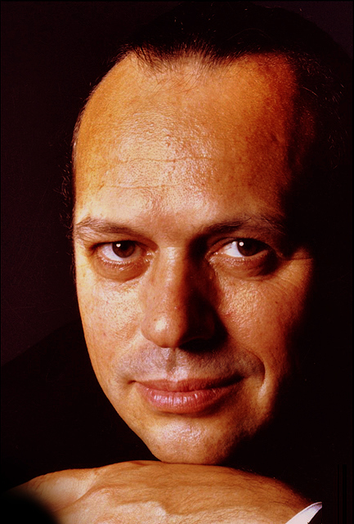
Vladimir Galouzine is a marvellous artist who surely needs no introduction to audiences. Nevertheless, surely, people would like to know more about his life. He was born on the 11th of June 1956 in the little town of Rubtsovsk in the Altay region of Russia. The nearest opera house was in Novosibirsk, about five hundred kilometres away, and operas were seldom shown on television, so that he had no idea about the genre in his childhood. Still, from his earliest years he loved to perform and to organize shows. He used to hang out bed sheets in the garden pretending that they were the curtains of a theatre, and to use this imaginary stage for the presentation of popular children songs. He recalls his childhood as being a very happy time, warmed by the boundless love of his parents.

On finishing school Vladimir entered a college in Barnaul which he thought would teach him how to become a popular singer. It turned out that the college trained managers for village clubs, who would have to direct amateur shows with country folk, and, without finishing the course, he ‘fled’ into the army, where he served in the Novosibirsk song and dance ensemble. Whether it was meant as joke or not, he recalls that on one occasion the whole ensemble, instead of going on leave, was taken to the Novosibirsk opera house as a punishment. That was the first time that he attended an opera – Mussorgsky’s Boris Godunov - which impressed him very deeply and defined his future destiny. He fell in love with opera and learnt all Chaliapin’s roles, attempting to sing them as a base.

Galouzine entered Novosibirsk conservatory at his first attempt. He was taught to sing as a baritone, although he kept on trying to prove that he was a tenor. He entered the Novosibirsk Musical Comedy theatre, where he did a great deal of acting and dancing as well as some singing, but he never abandoned his ambition to become real opera singer. He worked very hard sometimes performing twice a day in different productions and took part in the rehearsals as well. He studied new roles on his own. His eight years in Musical Comedy gave him an excellent school of acting with many skills and taught him to feel free on stage.

After a difficult start Vladimir at last began to sing in the Novosibirsk opera house. He worked there for about a year and then left for St. Petersburg. He acted there in Yuriy Alexandrov’s Chamber Music Theatre (now the St. Petersburg Opera Theatre), and after a short time was invited to sing Otello at the Mariinsky theatre. This was his entry onto the world stage. In the midi-nineties he left to live in Belgium and soon afterwards began to receive invitations to sing in the world’s leading opera houses.

Vladimir Galouzine is now regarded as one of the leading tenors of our time and appears with the most prominent opera theatres and symphony orchestras. He was born on 11 June 1956 in the town of Rubtsovsk in the Altay region of Russia. From his earliest years he loved to perform and organize shows, although the nearest opera house was in Novosibirsk, about five hundred kilometres away, and operas were seldom shown on television. Having completed his school education and wanting to become a popular singer, he entered a college in Barnaul, which, however, trained managers for village clubs. Without finishing the course, he joined the army, serving in the Novosibirsk song and dance ensemble. On one occasion, the ensemble, instead of going on leave, was taken to Novosibirsk Opera House as a ‘punishment’. Yet this first experience of opera—Mussorgsky’s Boris Godunov—impressed him very deeply and defined his future destiny. He fell in love with opera and learned all of Chaliapin’s rôles, attempting to sing as a bass. Galouzine entered Novosibirsk Conservatory, but his studies there did not proceed smoothly. Taught to sing as a baritone, he kept trying to prove that he was a tenor. His tutors considered that he lacked the qualities to become a professional singer, and he had difficulty finishing the Conservatory course. He then entered the Novosibirsk Musical Comedy Theatre and worked diligently (sometimes performing twice daily in different productions), but never abandoned his ambition to become an opera singer, studying new rôles on his own. Through eight years working in musical comedy he gained important acting and stage-craft skills. In 1988 he began to sing in the Novosibirsk Opera House, working there for about a year before leaving for St Petersburg, where he acted in Yuriy Alexandrov’s Chamber Music Theatre (now the St Petersburg Opera Theatre). Shortly afterwards, he was invited to sing Otello at the Mariinsky Theatre. This was his entry onto the world stage. In the mid-1990s he migrated to Belgium and began to receive invitations to sing in the world’s leading opera houses. He is considered to be the finest interpreters of the rôle of Hermann in Tchaikovsky’s Queen of Spades and one of today’s best Otellos. A close friend of Valery Gergiev, Vladimir Galouzine remains a member of the Mariinsky Theatre, with which he has participated in many tours throughout the world, and has interpreted most leading tenor rôles of the Russian and Italian repertoire, including Hermann (The Queen of Spades), The Pretender (Boris Godunov), Andrey Khovansky (Khovashchina), Grishka Kuterma and Prince Vsevolod (The Legend of the Invisible City of Kitezh and Maiden Fevronia), Vladimir Igorevich (Prince Igor), Alexey (The Gambler), Sergey (Lady Macbeth of Mtsensk), Calaf (Turandot), Radames (Aida), Pinkerton (Madama Butterfly) and Cavaradossi (Tosca), as well as the title rôles in Otello, Sadko and Don Carlos. He also performs for many of the most famous opera houses worldwide, including Opera Bastille, Paris, Lyric Opera, Chicago, Metropolitan Opera, New York, La Scala, Milan and the Royal Opera House, Covent Garden, London. Vladimir Galouzine is the subject of a recent biography written by Dr Natalia Bulgakova, which is available from the Royal Opera House Covent Garden, and Mariinsky Theatre.

He now also collaborates with the best opera houses worldwide, such as Opera Bastille Paris, Lyric Opera Chicago, Metropolitan Opera New York, La Scala Milan and Royal Opera House Covent Garden London, Houston Grand Opera.

