Israel Yinon, conductor

(Born in January 11, 1956 in Kfar Saba , Israel ) is a world renowned German, international conductor.
Yinon studied conducting, music theory and composition at the Rubin Academy of Music in Tel Aviv (1981-1984) and at the Music Academy in Jerusalem (1985-1988) among others, Noam Sheriff and Mendi Rodan. In May 1991 he conducted the nationwide watch live opening concert of the newly founded Germany transmitter culture . In 1992, he first conducted the Brno Philharmonic Orchestra, with whom he subsequently completed a tour of Germany and his debut CD with the recording of the symphonic works of Viktor Ullmann's recorded. This CD was awarded the Prize of the German Record Critics' award. Have since conducted a number of recordings for Decca Yinon, German Grammophon, Koch, CPO and other labels appeared.
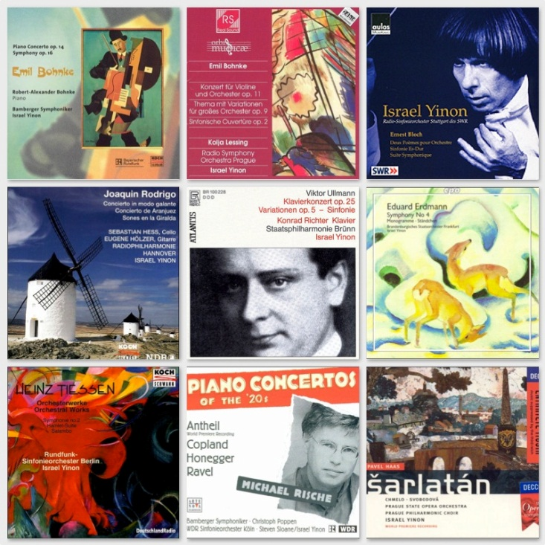
Apart from the classical repertoire, Yinon devoted mainly to the discovery of forgotten and unknown works. He sat down in particular in the Third Reich as " degenerate "forbidden composers like Hans Krasa , Pavel Haas and Erwin Schulhoff one, but also for representatives of German Expressionism forgotten how Heinz Tiessen and Eduard Erdmann . Moreover, he has established himself as a lawyer living musical composer name. For example, he brought the opera The Royal Game of Violeta Dinescu for the premiere (at the Schwetzingen Festival 1995).
Israel Yinon served as guest conductor with numerous orchestras, including the BBC Symphony Orchestra, the Jerusalem Symphony Orchestra, the London Royal Philharmonic, Royal Antwerp Flemish Philharmonic, the NDR Radio Philharmonic, the Vienna Symphony and the German Symphony Orchestra Berlin.
Yinon interpretations are marked by faithfulness, sensitivity and precision craftsmanship. At the same time his conducting style is characterized by vitality and temperament.

