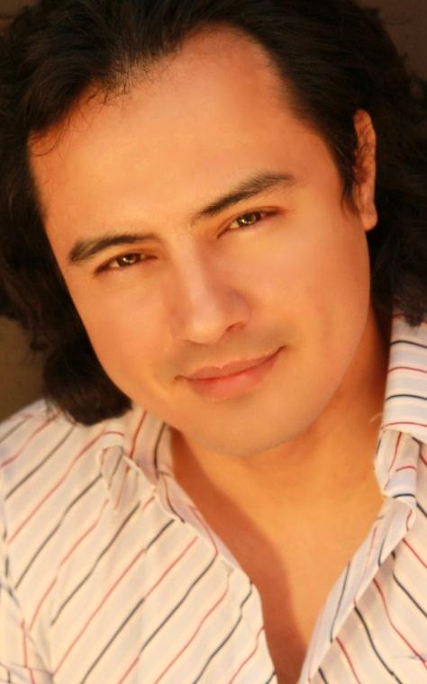

Tenor
Jesús Daniel Hernández
United States (+1) 202 340-7705
jesusdanielhernandez@gmail.com

Dietsch Artists International
James Dietsch
+1 973 763 8836
dietsch@dietschartists.com
www.dietschartists.com

Mr Hernández was born and raised in Juarez Mexico, and moved to the United States as a teenager. In 2003 Mr Hernández chose to enlist in the US Army, and soon after, volunteered to serve in a Chemical Unit being deployed to Iraq. In 2007, a chance encounter with Plácido Domingo in San Antonio, TX changed his life. After a concert given by Maestro Domingo, Specialist Hernández asked if he could sing for the great tenor to see what the Maestro thought of his voice. Upon hearing the young soldier sing, Maestro Domingo invited the tenor to join the prestigious Plácido Domingo-Cafritz Young Artist Program with the Washington National Opera. After an honorable discharge in 2008, Mr Hernández moved to Washington, DC to pursue his boyhood dream of being a professional singer.
While a participant in the Domingo-Cafritz Young Artist Program, Mr Hernández performed with The Washington National Opera in the productions of Lucrezia Borgia-G. Donizetti, La Traviata-G. Verdi (YA), Falstaff-G. Verdi (WNO Look-In), Marriage of Figaro-W. Mozart, and in Hamlet-A. Thomas. Mr Hernandez’s other roles have included performances in Rigoletto-G. Verdi, La Boheme-G. Puccini, The Merry Widow-F. Lehar, A hand of Bride-S. Barber, Pulcinella-I. Stravinsky, Andrea Chenier-H. Giordano, and the zarzuela El duo de la Africana. His experience includes concert performances for NEA Opera Honors ceremonies, the Horatio Awards at the United States Supreme Court, and numerous concerts in Europe. His upcoming roles and performances include Alfredo in La Traviata, Andrea Chenier on the title role, and Pinkerton in Madama Butterlfy.
Mr. Hernández has been conducted on numerous occasions by Plácido Domingo and sang with Maestro Domingo in his “From My Latin Soul” concert in Washington, DC. It was said of this performance that Mr Hernández and the other young tenor in the program, “already possess powerful voices, great diction and an exciting stage presence. When they sang with Mr. Domingo it seemed, if only for a moment, that the Three Tenors were in a process of rebirth.” It is said that Mr. Hernandez possesses a “sensational tenor voice [that] has a clarion purity that could fill a cavernous auditorium… He knows how to project a song so you feel it…And Hernandez ecstatically delivers a gracious, thoroughly engaging, straight-from-the-heart, fully enjoyable, tour-de-force performance.”

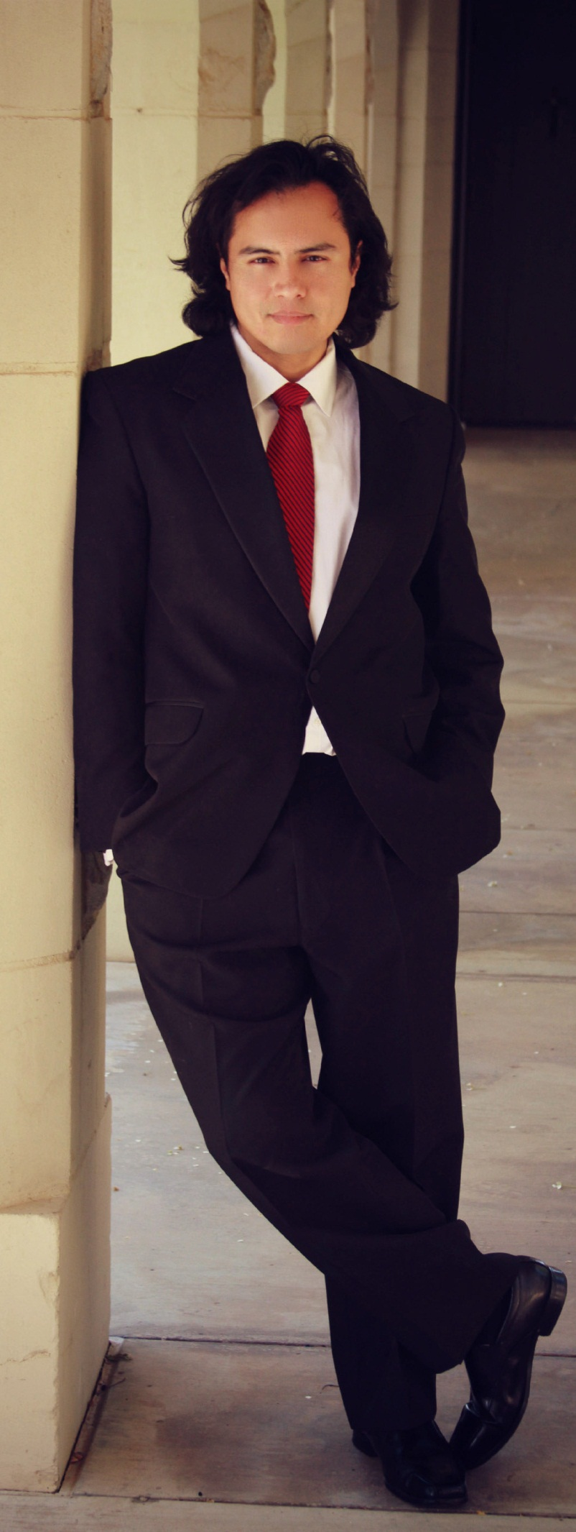
Tenor
Jesús Daniel Hernández

Repertoire
Andrea Chénier - Andrea Chénier
Rodolfo – La Boheme

Alfredo – La Traviata

Pinkerton – Madama Butterfly

Turiddu – Cavalleria rusticana

Canio - Pagliacci

Tenor (solo) – Pulcinella, Stravinsky

Il Duca di Mantova - Rigoletto
Camillo – The Merry Widow
Bill – A Hand of Bridge
Fenton – Falstaff
Guiseppini - El Dúo de La Africana

Prince Charming – Into the Woods

Jesús Daniel Hernández
Dietsch International Artists
+1 973 763 8836
dietsch@dietschartists.com
www.dietschartists.com

SELECT CONCERT PERFORMANCES
Tenor soloist, Pulcinella, Stravinsky  Duke of Mantua, Rigoletto | BSO Meyerhoff  Hungarian Embassy, Washington DC |  | Marin Alsop  Stephen Czarkowski | 2010  2010
Plácido Domingo’s From My Latin Soul Concert | DAR Constitution Hall |  | Alondra de la Parra | 2009
NEA Opera Honors | US Supreme Court |  | Ken Weiss | 2009
Domingo-Cafritz Young Artist Concert | Strathmore Theater |  | Plácido Domingo | 2009
NEA Opera Honors | Harman Theater |  | Israel Gursky | 2008
Invited Artist | The National Council of La Raza Capital Awards Gala |  |  | 2013
Andrea Chénier selected works |  | Arpino, Italy |  |  | 2012
Concerto Dei Due Tenore |  | Sora, Italy |  |  | 2012
De Mi Corazon Latino |  | In Series, Washington, DC |  |  | 2012
Featured Artist |  | The National Hispanic Media Coalition: Latino Mediacon Expo, Los Angeles, CA |  |  | 2012
Invited Artist |  | Greater Washington Hispanic Chamber of Commerce Gala |  |  | 2012
Tres Mas Tenors |  | Opera Piccola, San Antonio, TX |  |  | 2012
Fiesta Mexicana: Celebrating the Bicentennial of the Independence of Mexico |  | Kennedy Center for the Performing Arts |  |  | 2010
Horatio Awards Presentation |  | US Supreme Court |  |  | 2010
Mexican Boleros Concert |  | Kennedy Center for the Performing Arts |  |  | 2010
Selected Arias and Duets |  | Opera Guild of Northern Virginia |  |  | 2010
Selected Works |  | Salone del Palazzo di Alatri in Italia |  |  | 2010
Smithsonian American Art Museum Steinway Series |  | McEvoy Auditorium |  |  | 2010
Mexico Bello |  | Living Arts Concert Series |  |  | 2011
Domingo-Cafritz Young Artist Zarzuela Concert |  | Mexican Embassy |  |  | 2009
Guest Artist |  | Amarillo Opera |  |  | 2007, 2008, 2009. 2011
Additional concerts include performances at the Hungarian, Austrian, and French embassies, performances for the ambassadors of Spain, El Salvador and Liechtenstein, and performances at the residence of the Moroccan ambassador and the residence of the Columbian ambassador.

COMPETITIONS
Concorso Lirico Internazionale, Umberto Giordano – Finalist
Nominated as Best actor for the Role of Rinuccio in the DC Theater Scene.

COACHED OPERA ROLES
Role | Work | Coach
Fenton | Falstaff | Ken Weiss
Alfredo | La Traviata | Louis Salemno
Il Duke | Rigoletto | Louis Salemno
Andrea Chénier | Andrea Chénier | Donato DiStefano
Pinkerton | Madama Butterfly | Donato DiStefano
Turiddu | Cavalleria Rusticana | Donato DiStefano

EDUCATION and TRAINING
2008-2010 Washington National Opera: Domingo-Cafritz Young Artist Program
Teachers  Donato DiStefano  Nicola Martinucchi | Coaches  Ken Weiss  Anthony Manoli  Louis Solemno  Gerald Moore | Master Classes  Nino Munic  Leon Major  Donato DiStefano  Marta Domingo
Directors  Ted Huffman  John Pascoe  Thaddeus Strassberger  George Hogan  Erick Shepard  Carlos de la Garza | Conductors  Plácido Domingo  Patrick Fournillier  Israel Gurski  Dr Hugh Cardon  Michael Rossi  Lucy Arner

PREVIOUS EXPERIENCE
2003-2008 US ARMY CBRNE Chemical Corps

* Upcoming Performance

