Jin-Won Park, Lyric Soprano
Curriculum Vitae
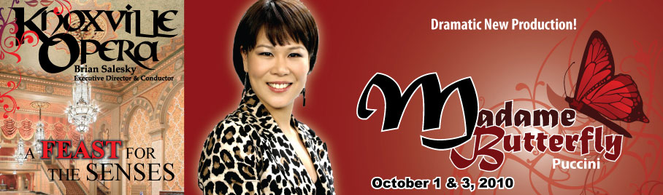

Education:
Present ∙ Role preparation with James Dietch, NY U.S.A.
Present ∙ Additional study with soprano Hei-Kyung Hong, NY, U.S.A.
2006 ∙ The University Mozarteum Salzburg, Austria
Studied under Zakotink Breda post graduate Lied class
2004 ∙ The University Mozarteum Salzburg, Austria
Studied under professor Lilian Sukis master’s degree in opera graduated first in class
1999 ∙ The University Mozarteum Salzburg, Austria
Studied under professor Horiana Branisteanu bachelor degree in voice graduated first in class

Performance Experience:
2010 ∙ Cio-cio san in Puccini’s “Madame Butterfly”; Knoxville Opera, US Debut. TN, U.S.A.
2010 ∙ Soloist at Beethoven Symphony No. 9: Hyo Shin Presbyterian Church of New York NY, U.S.A.
2010 ∙ Main performer at solo concert held by Korean Consulate General, Ministry of Foreign Dalian, China
Affairs and Trade
2010 ∙ Main performer at Benefit Song Concert for the North Korean Refugees; the New York Art Song NY, U.S.A.
2010 ∙ Michaela in Bizet’s “Carmen”, Mimi in Puccini’s “La Boheme”; NY Lyric Opera NY, U.S.A.
2010 ∙ La Contessa di Almaviva in Mozart’s “Le nozze di Figaro”; KALIOPE Opera NY, U.S.A.
2009 ∙ Soloist at Handel’s Messiah; Hyo Shin Bible Presbyterian Church of New York NY, U.S.A.
2009 ∙ Main performer at Benefit Song Concert for the North Korean Refugees; the New York Art Song NY, U.S.A.
2008 ∙ Soloist at Handel’s Messiah: Hyo Shin Presbyterian Church of New York NY, U.S.A.
2006 ∙ Morzart Ensemble tour concert Austria & Germany
2005 Erste Dame in Mozart’s “Die Zaubelfloete”; Chimsee festival Chimsee, Germany
2004 ∙ La Contessa di Almaviva in Mozart’s “Le nozze di Figaro” Mozarteum orchestra, Grosser Saal l Salzburg, Austria
2004 ∙ Mimi in Puccini’s “La Boheme”, Mozarteum orchestra, Grosses Studio Salzburg, Austria
2003 ∙ Arminda in Mozart’s “La finta giardiniera” Mozarteum orchestra, Grosses Opernstudio Salzburg, Austria

2002 ∙ Fiordilligi in Mozart’s “Cosi fan tutte “; Mozarteum orchestra, Grosses Opernstudio Salzburg, Austria
2002 ∙ Pamina in Mozart’s “Die Zauberfloete” ; Mozarteum orchestra , Grosses Opernstudio Salzburg, Austria
2002 ∙ Main performer at prestigious concert celebrating the 10th treaty between China and Korea, Dalian, China
∙ Various solo concerts Korea and China
∙ Various concerts as a volunteer, performed for handicapped people and elderly people Salzburg, Austria

Prizes:
2010 ∙ Audience award- New York Lyric Opera Vocal Competition New York, U.S.A.
2006 ∙ Finalist “International Mozart” Competition Salzburg, Austria
2006 ∙ Prize in Morzarteum Ensemble Competition Salzburg, Austria
2000 ∙ 4th Prize in the “Ferruccio Tagliavini” Voice International Competition Graz, Austria
2000 ∙ Awarded the Austrian Government Minister of Culture music scholarship Salzburg, Austria

Upcoming Engagement:
2011 ∙ May/Liu in Puccini’s “Turandot” concerts: New Jersey State Opera NJ, U.S.A

Master courses:
2007 ∙ Soprano Barbara Bonney Austria
2004 ∙ Soprano Mirella Freni Italy
1999 ∙ Mezzo Soprano Marian Lipovsek Austria

